Add a Patient Action Codes

Action Codes on Dialogue

PATIENT

Look up an existing person: This lookup, whether an icon (magnifying glass or the words are a hyperlink) should take user to a search dialogue which allows the user to search for a person—see below. ***Note the method chosen for lookup should stay consistent throughout the application. **

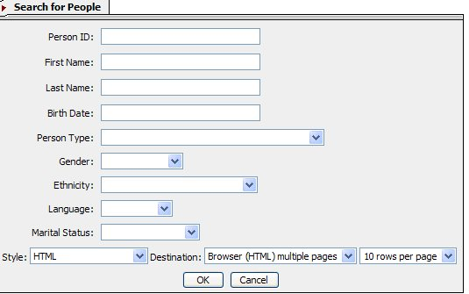

Fig 2a
This is a good search engine, because it is a search engine for all persons.

Add

- If birth date has to be in a certain format, then to the left of the Birth date box, should be a message stating the format (mmddyyyy). **Note: Anywhere in the application,where information should be entered in a certain format, there should be a small example of it near the field.

Once the user clicks OK, the system should pull up the results. See below. ***Note: Search results include all types of persons.

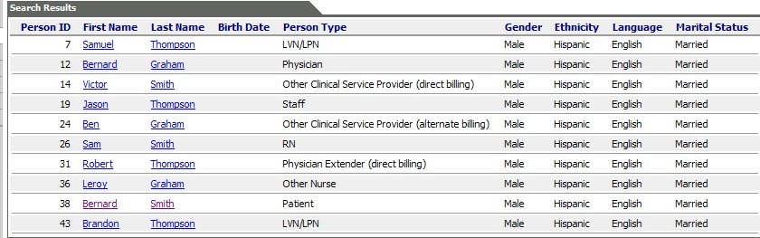
Fig 2b

Edit

- The hyperlink to the patient summary should be on the person ID.
- Switch Last Name column with First Name Column
- Sort in alphabetical order by Last Name.
- If a person is in several Person Types-either all types should be listed under the Person Type column or the person should have a row for each person type. (These will appear beneath each other since the persons will be listed alphabetically.)

Function

a) If a person is found in Org but not for Patient Person type, then the user should be able to click the Person ID (the hyperlink) and an additional dialogue should come up:
***If Patient ID hyperlinks to patient summary- can it also function to bring up the above dialogue? If not then can the name be made a hyperlink to summary page and Person ID made to be the link to above dialogue? *****

Do you want to add [Person_id] to Patient Type?→Yes→Dialogue for Add-a-Patient comes up with as much information as possible auto filled→User enters any additional information→User chooses Next Action→User clicks [Ok]→Application performs Next Action.
**See further down for descriptions on next action. **
Or

Do you want to add [Person_id] to Patient Type?→No→Application takes user back to blank Add-a-Patient Dialogue.

- If person is not found in the results of the search, the user should be able to close the search results and the application should take the user back to the blank “Add-a-Patient” dialogue.

RESPONSIBLE PARTY

Look up at Responsible Party

The location of Responsible Party on Medspective is a good place, but it needs to be more users friendly. The fields in Physia are a good example:

Look up an existing responsible party: This lookup, whether an icon (magnifying glass or the words are a hyperlink) should take user to a search dialogue which allows the user to search for a person—see below. ***Note the method chosen for lookup should stay consistent throughout the application. **

Add

- If birth date has to be in a certain format, then to the left of the Birth date box, should be a message stating the format (mmddyyyy). **Note: Anywhere in the application that information should be entered in a certain format, there should be a small example of it near the field.

Once the user clicks OK, the system should pull up the results. See below. ***Note: Search results include all types of persons.

Edit

- The hyperlink to the patient summary should be on the person ID.
- Switch Last Name column with First Name Column
- Sort in alphabetical order by Last Name.
- If a person is in several Person Types-either all types should be listed under the Person Type column or the person should have a row for each person type. (These will appear right next to each other since the persons will be listed alphabetically.)

Function

a) If a person is found in Org but not for Responsible Person type, then the user should be able to click the Person ID (the hyperlink) and an additional dialogue should come up:
***If Patient ID hyperlinks to patient summary- can it also function to bring up the above dialogue? If not then can the name be made a hyperlink to summary page and Person ID made to be the link to above dialogue? *****
Do you want to add [Person_id] to Responsible Party Type?→Yes→Dialogue for Add-a-Responsible Party comes up with as much information as possible auto filled→User enters any additional information→User clicks [ok]→ Application auto fills Person Id in the blank for Responsible Party.

Or

Do you want to add [Person_id] to Responsible Party Type?→No→Application takes user back to blank field at Responsible Party.

b) If person is not found in the results of the search, the user should be able to close the search results→ click a hyperlink, to add Responsible Party, next to “look up” → application should take them to a “Add Responsible Party Dialogue”. (See below)
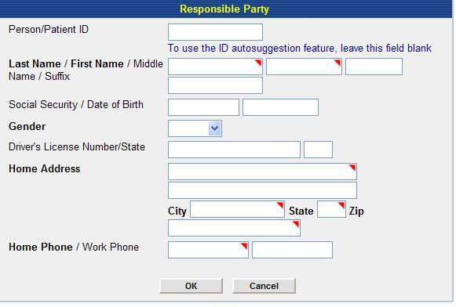
Fig 3a

Add
- Need required marker next to Gender (red triangle is used in Physia).
- If a certain format is needed for SSN, Date of Birth or Phone number, then to the right of the blanks should be an example of format.
User completes dialogue→[OK]→application suggests 3 Person ID→User chooses one→[OK]→application should auto fill the Responsible Party Person ID in the appropriate blank in the Add-a-Patient screen.

EMPLOYER

Look up Employer
The Employment section in Medspective is good and needs little editing.

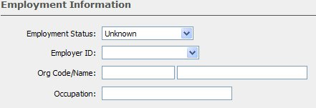
Fig 4a

Remove
Org Code/Name

This lookup, whether an icon (magnifying glass or the words are a hyperlink) should take user to a search dialogue which allows the user to search for an Employer org.—see below. ***Note the method chosen for lookup should stay consistent throughout the application. **
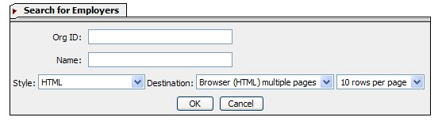

Once the user enters search criteria and clicks [OK], the system should pull up the results from the search. (See below)

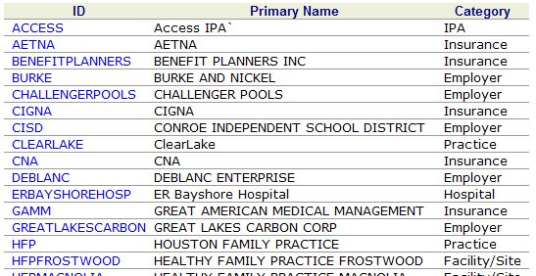

***Note: Application should only pull in orgs in Category “Employer”

Function

a) The user should click the Org Id → the application should take the user back to Add-a-Patient Dialogue →application auto fills Employer Id in Employer Id field.

Or

- If the user does not see the Employer listed, then the user closes search results window→application takes user back to Add-a-Patient screen→user chooses Add-an-Employer Org icon or hyperlink (again consistency on how application does this) →Application takes user to Add-Employer Dialogue. (See below)

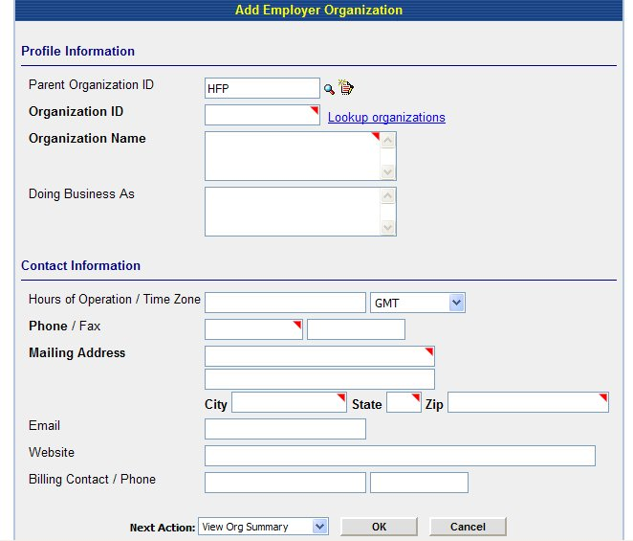

Remove:
- Parent Org ID, including the look up and add features (this should default to main org)
- Doing Business As
- Hours of Operation/Time Zone
- Billing Contact /Phone
- Remove required field indicators on Phone Number and Mailing address
- Remove Look up Organizations

Edit:
Ignore Next action since the application will take user back to Add-a Patient Dialogue when complete.

Function

Once the user enters information and chooses [OK]→Application takes user back to Add-a-Patient Dialogue→Application auto fills created Employer Id.

CARE PROVIDER

Look up an existing Care Provider party: This lookup, whether an icon (magnifying glass or the words are a hyperlink) should take user to a search dialogue which allows the user to search for a person—see below. ***Note the method chosen for lookup should stay consistent throughout the application. **
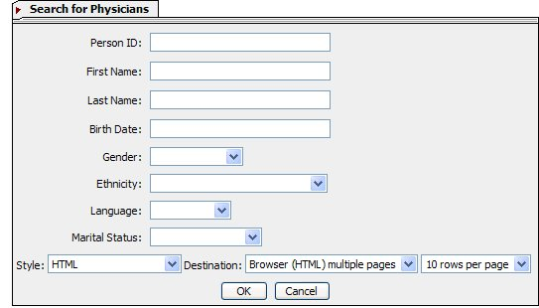
Fig 5a

Remove:
- Birthdate
- Gender
- Ethnicity
- Marital Status

Application should pull up search results (See below)

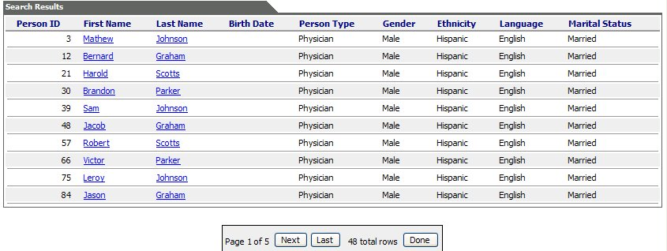

Remove:
- Birth date column
- Gender
- Ethnicity
- Marital Status
Edit:
- Sort in alphabetical order by last name
- Switch First Name column with Last Name Column
- The hyperlink should be the Person Id.
- Search results should pull up all types of Care Providers and Physicians.
- If a person is in several Person Types-either all types should be listed under the Person Type column or the person should have a row for each person type. (These will appear right next to each other since the persons will be listed alphabetically.)

Function

If a person is found in Org but not for Referring Physician Person type, then the user should be able to click the Person ID (the hyperlink) and an additional dialogue should come up.
***If Patient ID hyperlinks to patient summary- can it also function to bring up the above dialogue? If not then can the name be made a hyperlink to summary page and Person ID made to be the link to above dialogue? *****

a) Do you want to add [Person_id] to Referring Physician Type?→Yes→Dialogue for Referring Physician comes up with as much information as possible auto filled→User enters any additional information→User chooses Next Action→User clicks [Ok]→Application suggests a Person Id →User chooses one→clicks [OK]→Application takes user back to Add-A-Patient Dialogue.

Or

b) Do you want to add [Person_id] to Patient Type?→No→Application takes user back to blank Add-a-Patient Dialogue.

If person is not found in the results of the search, the user should be able to close the search results and the application should take the user back to “Add-a-Patient” dialogue.→User clicks Icon or hyperlink to Add Care Provider→Application opens up a window with Add-a Referring Physician Dialogue. (See below).

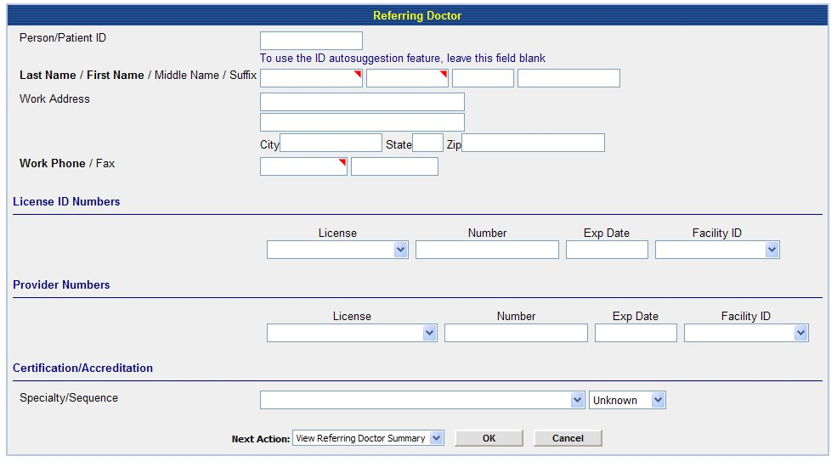

The user completes the necessary fields and clicks [OK]→Application suggests Person ID→User chooses one→clicks [OK]→Application goes back to Add-a-Patient Dialogue and auto fills Referring Physician ID.

NEXT ACTION

Once the user completes all necessary fields in Add-a-Patient Dialogue, they should choose a Next Action (see below)
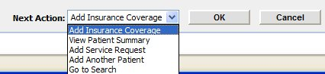
Fig 6a
**Note: not able to capture last 2 Next actions: Return to Home, Go to Work list

Add insurance: Takes user to Add Insurance Dialogue (Different Document)
View Patient Summary: Takes user to Patient Summary Page (Different Document)
Add Another Patient: Takes user to a new Add-a-Patient Dialogue (Different Document)
Go to Search: Takes user to Search engine for Person (see page 1).
Return to Home: Takes user to their Home Page (Different Document)
Go to Work List: Takes user to List of Work List (Different Document)

Remove:
“Add Service Request”

Function:

User Clicks [OK] →Application suggests 3 Person Ids→Application should add an [OK] [Cancel] Button next to suggestions→User chooses Person Id→Application adds Person and performs Next Action.

